**AWS S3 Bucket**

Creation of S3 Bucket and accessing the files from S3 bucket

1. Click on All Services and select S3

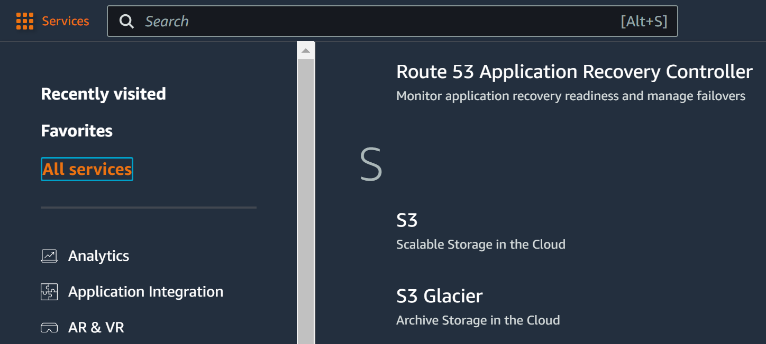

1. Click on” Create Bucket”

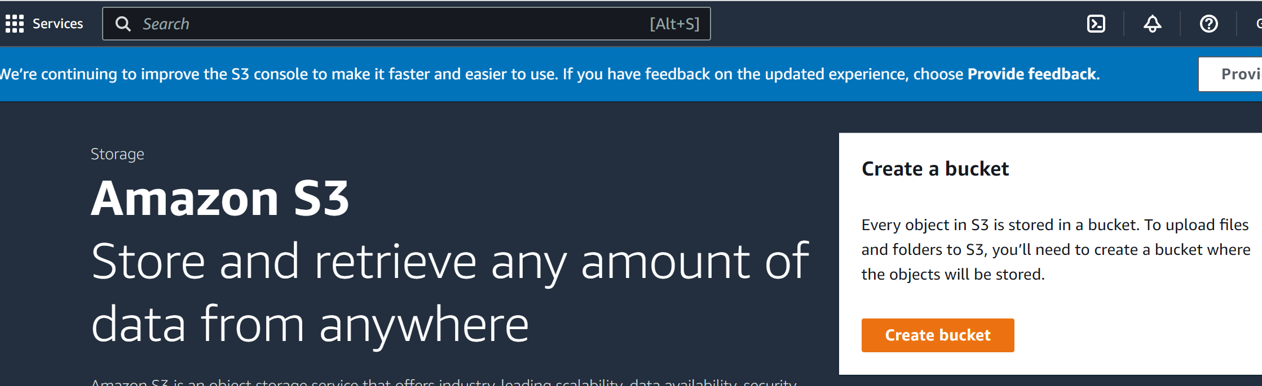

1. Enter the details and select the required config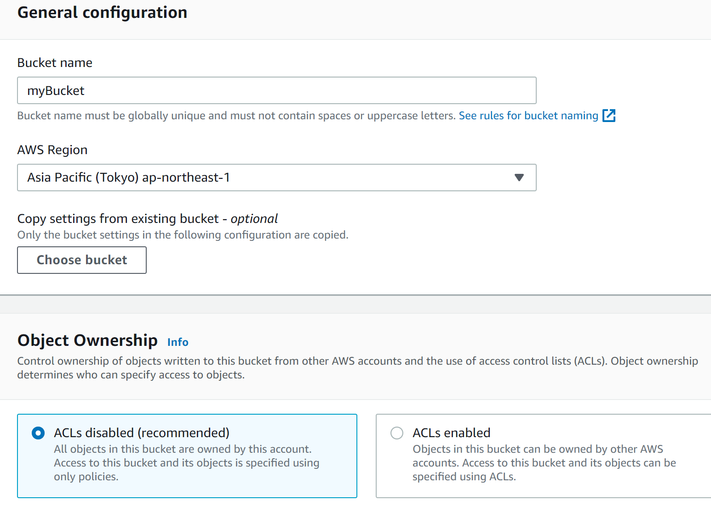
2. Click on Create Bucket after Entering all details

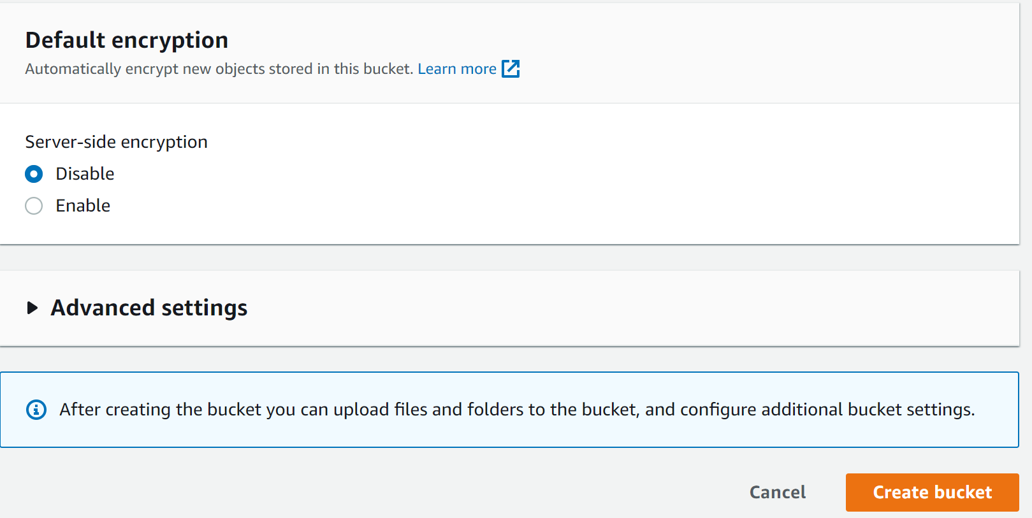

1. To upload files

* Click on name of the bucket

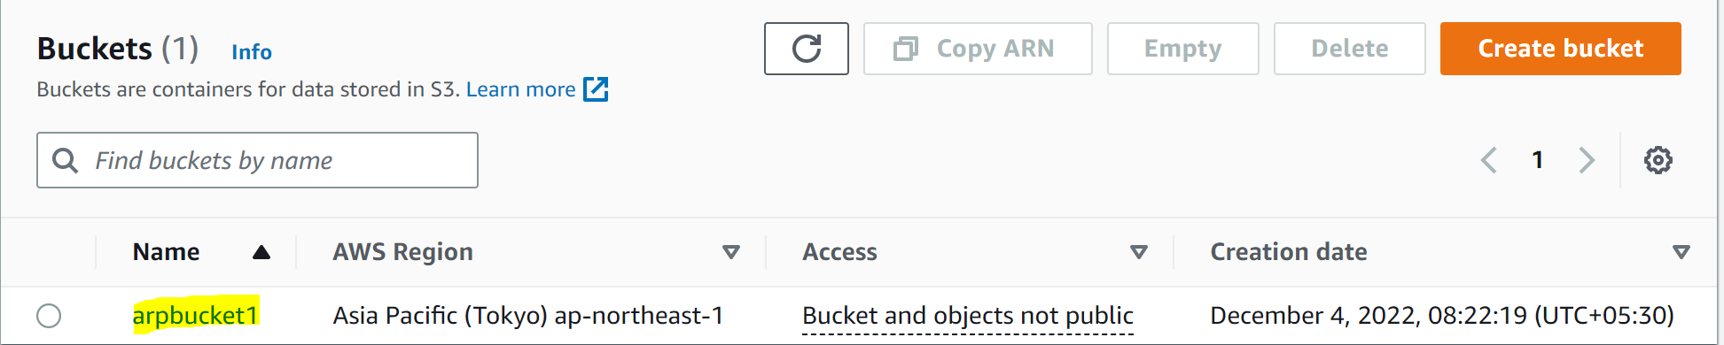

* Click on Upload

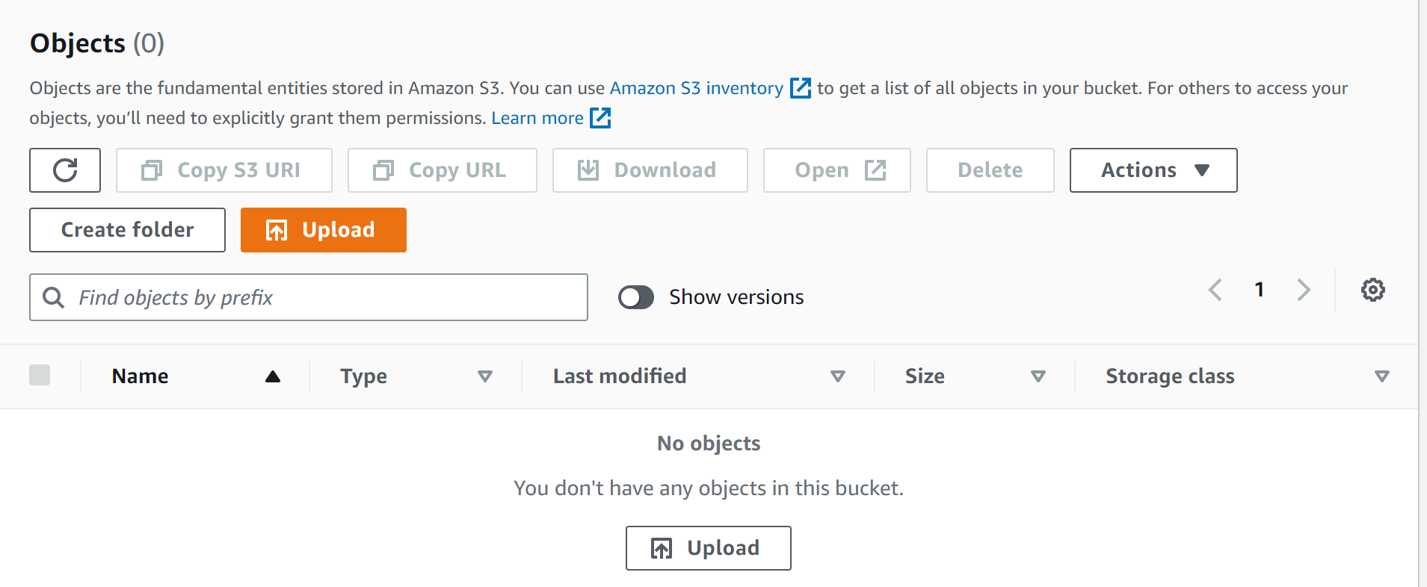

* Click on Add files

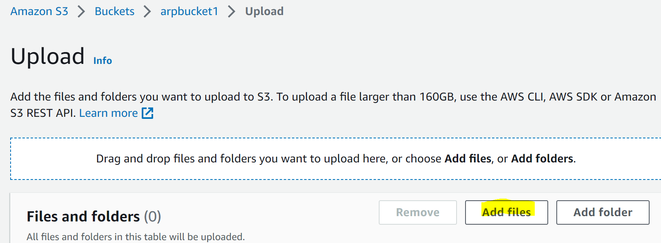

* Select the files to be uploaded and and click on Upload

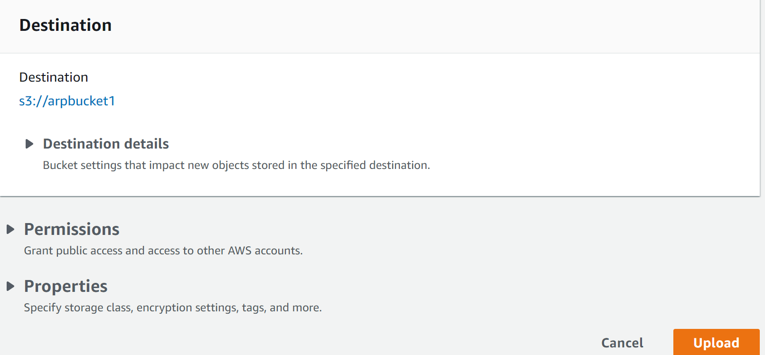

1. Download the file from

* Click on the name of the bucket

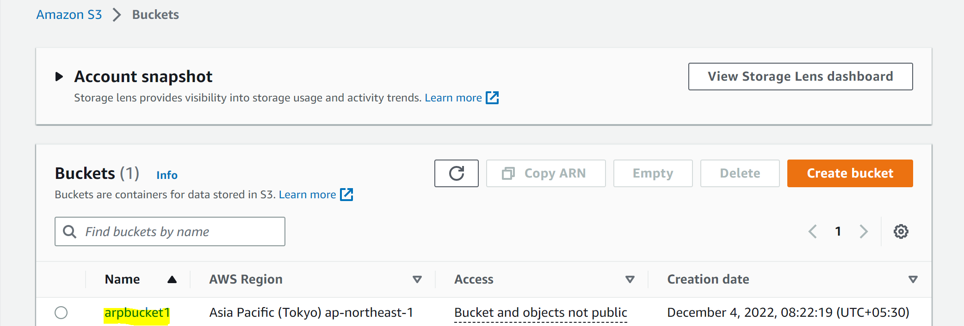

* Click on the name of the file and click on Download

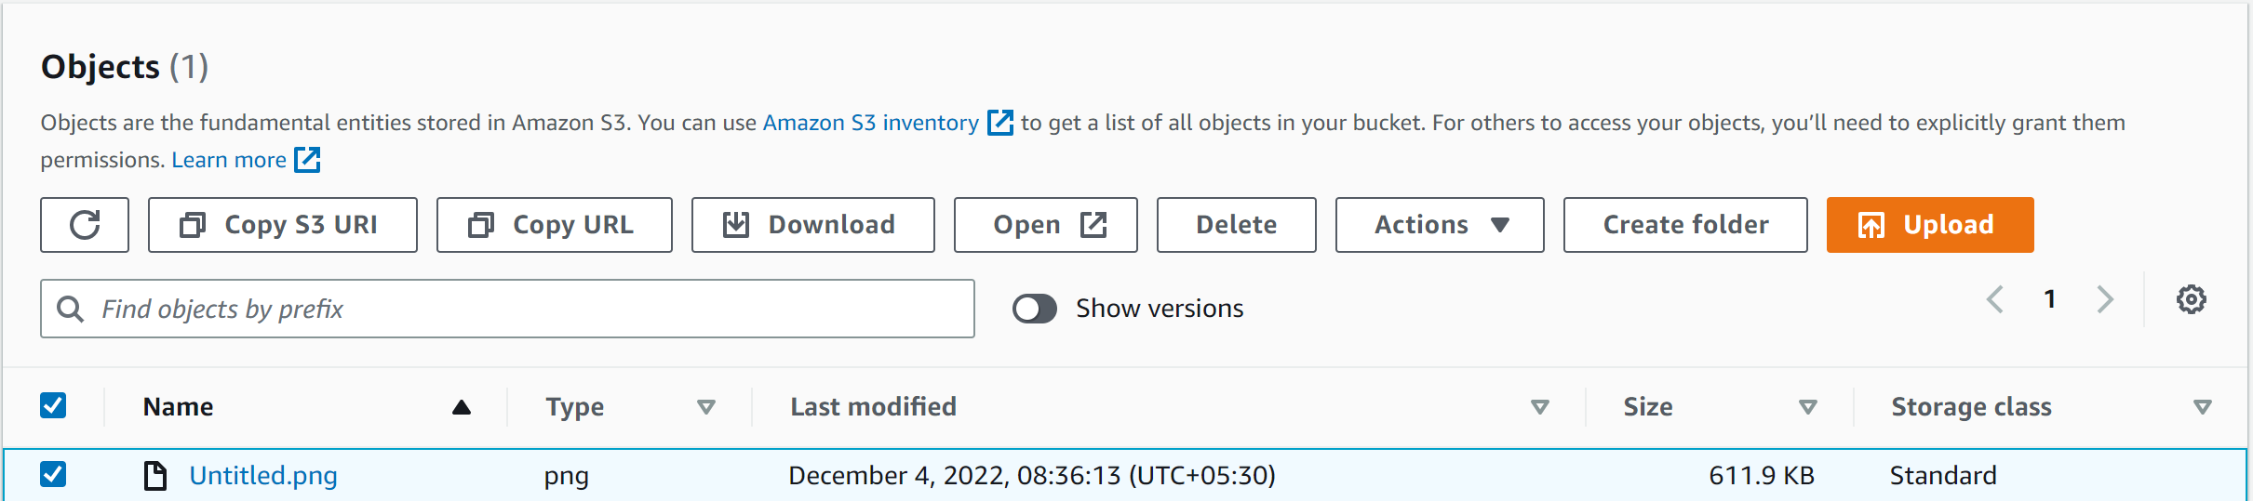

* The file will be available in the file system